附件2 | 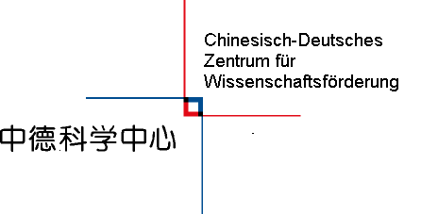

APPLICATION FOR THE LINDAU PROGRAM

Topic | Physics
Time of the Meeting | 2019.06.30-07.05
Time of the Science Tour | Details will be announced later
Place | Lindau and other German cities during Science Tour
Name |  | Sex
Date of Birth |  | Place of Birth
Institute/University
Adress/Zip Code
Phone
E-Mail
Field of Research
Certificates of English and other languages
Expeceted Date of Graduation

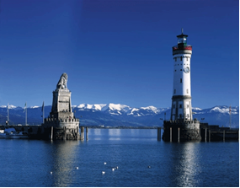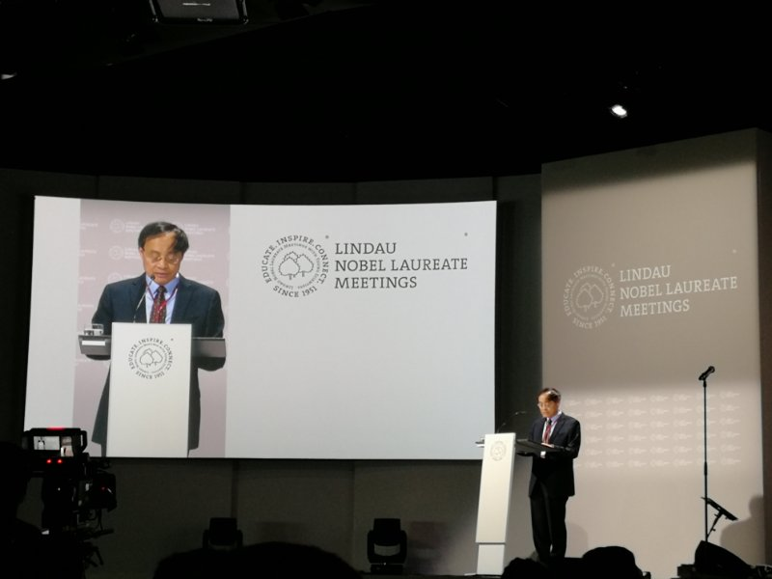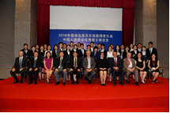

1. Statement of your qualifications and reasons for wishing to attend the Nobel Laureate Meeting, especially:
a. Your research field: Please give a brief description of your thesis subject and an outline of your research plan, describing the results you have already obtained and ongoing work.
b. What influenced your decision to pursue a PhD and to choose your particular topic?
c. International experience: Have you had opportunities to discuss your research internationally, e.g. with visiting researchers from abroad, at international conferences or on visits to foreign research labs?
d. What is your career plan for the future?
(use Arial 12 point characters, single-spaced)

Declaration

We hereby recommend our student for participation in this year's Lindau Program by the Sino-German Center.

_____________________ _______________________
Signature of applicant Seal of university

Attachment

- Letter of recommendation from your thesis advisor and/or the academic committee of your current institution.
- Curriculum vitae and publication list (5 most relevant publications for all participants) (If you are not the only author, please list your co-authors).
(one page at most, use Arial 12 point characters, single-spaced)
- Copy of ID
- Published articles
- Other distinctions and scholarships
- Table of recommended students (by university, sealed)

